Database Administration Portal

Data Masking and Export

Contents

1. Introduction 4

1.1 Purpose 4

1.2 System Overview 4

1.3 Definitions and Acronyms 4

2. Design Considerations 4

2.1 Assumptions 4

2.2 Constraints 4

2.3 System Environment 4

3. Architecture 5

3.1 Overview 5

4. Database Schema 5

5. User Interface Design 5

5.1 Login Form 6

5.2 Database Administration Portal 6

5.2.1 Database Administration Portal – Table Information 6

5.2.2 Database Administration Portal – Mask Data Types 7

5.3 Mask and Export – Generation of Excel 7

6. Further Scope - TBD 8

# Introduction

## Purpose

This design will detail the implementation of the requirements as defined user requirements document. As a data base administrator, should able to connect any RDBMS to view the all the tables and export the data by proper masking strategies.

## System Overview

A data base administrator can login to the system by proper JBDC connection string, user name and password where list of all the existing tables are displayed. Administrator can expand the tables to view the table information and select list of columns for Masking. Once after list of the columns marked for masking, Administrator can click ‘Mask and Export’ button to download the system data. If Administer can directly click ‘Export’ button to export the data without Masking as well.

## Definitions and Acronyms

**Data Mask** – Data masking is a method of creating a structurally similar but inauthentic

version of an organization's data.

# Design Considerations

**Basic Layout** - Considered basic layout and use simple styles and jQuery to show the required table(s) information.

**Any RDBMS** – Considered only couple of databases, MySQL and PostgreSQL, for the application but easily extendable for any RDBMS.

## Assumptions

Implementation for one of the paths to import data back from the generated excel into the target database isn’t considered as the process is like the data export process (vice versa case)

## Constraints

Java Heap and GC are required to set accordingly based on the data base load to avoid Java Heap issues.

## System Environment

The Database Administration Portal application developed using JSP framework as Dynamic Web Project where it can access (Read) the database information for the given RDBMS connection. Apache Tomcat 8.5 used as a server to host the application. Third party software Apache POI is been used to generate Excel file with the embedded data.

# Architecture

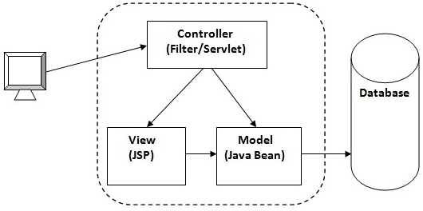

## Overview

Controller will handle the incoming request with the required sensitive data (connection_string, username, password) to establish the connection with the required data base and respond back with the available list of tables as a JSP view.

Once controller receive the request to mask and export the data, a query for each selected table gets executed to get the masked data which embedded into a downloadable excel file.

# Database Schema

NA – The application doesn’t require any schema to host the application but requires the connection url with authentication details to connect specified data base schema.

# User Interface Design

This section provides user interface design descriptions that directly support construction of user interface screens.

## Login Form

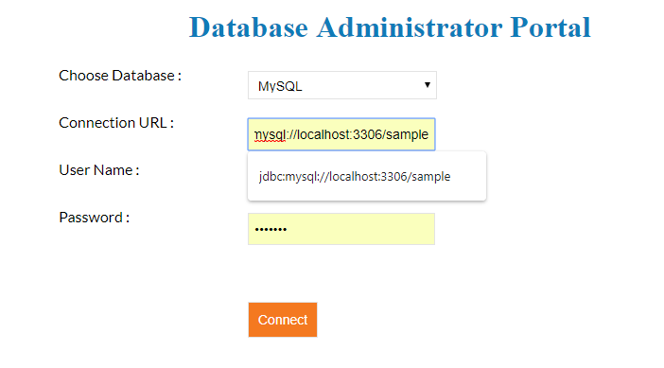

## Database Administration Portal

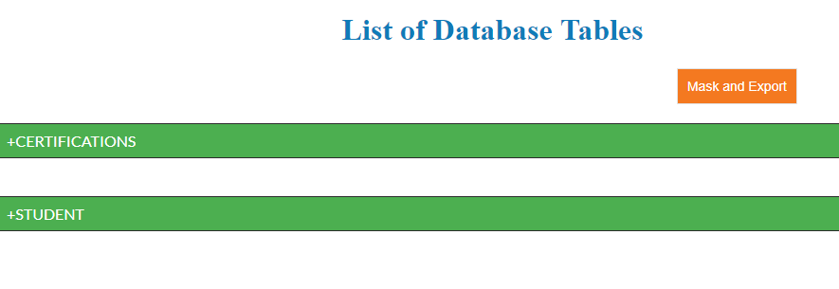

### Database Administration Portal – Table Information

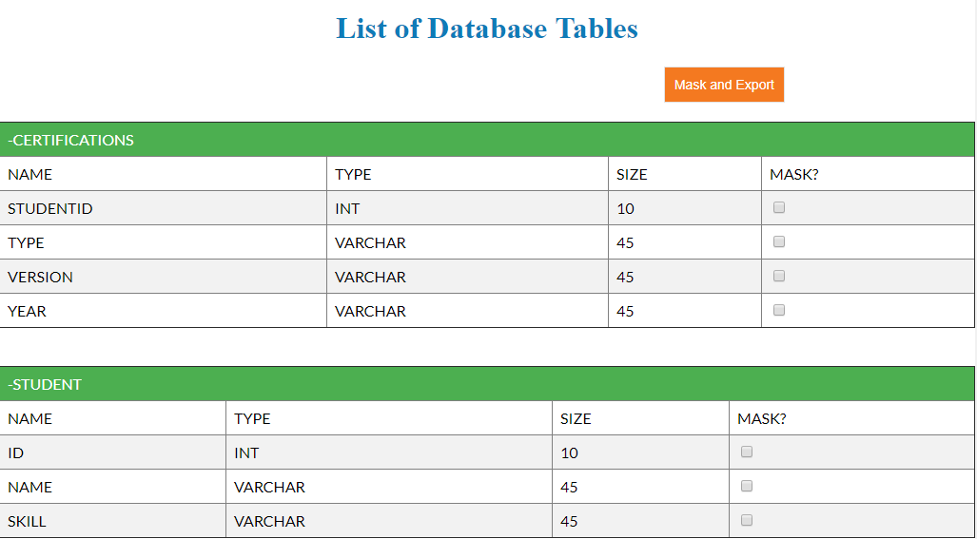

### Database Administration Portal – Mask Data Types

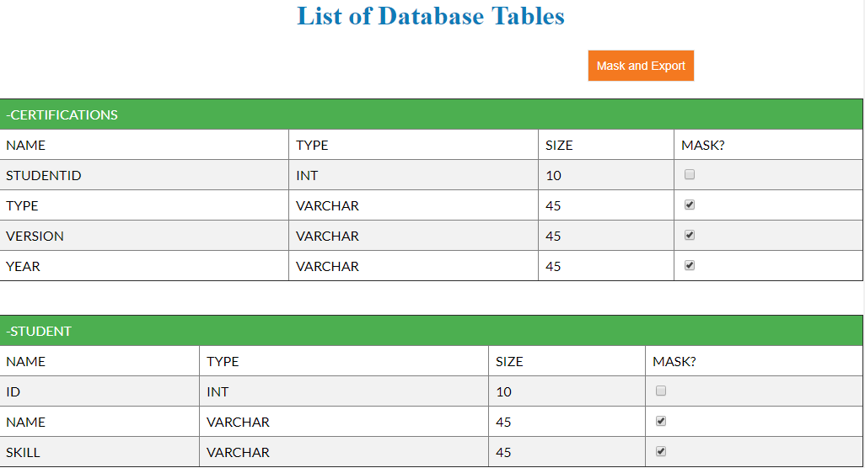

## Mask and Export – Generation of Excel

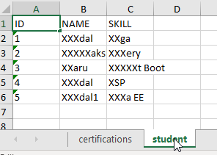

# Further Scope - TBD

Administrator should able to export the schema and could be able to import the data automatically without exporting the data.